**Ex:** 2

**Date:** 10/10/2020

**Aim:**

To create a python function countX(ls, x) to count the number x in a given list of numbers.

**Program:**

def countX(ls,x):

c=0

for ele in ls:

if(x==ele):

c=c+1

return c

f=int(input("Enter size of arr:"))

ls1=[]

for i in range(0,f):

temp=int(input())

ls1.append(temp)

x=int(input("Search Element:"))

co=countX(ls1,x)

print("Count:",co)

**Output:**

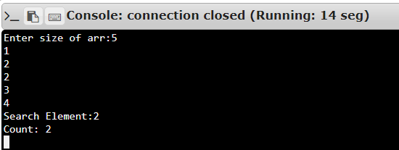

**Result:**

Thus creating python program to make a function for finding occurrences of the a number in an array list.

**Link:**

<http://103.53.53.18/mod/vpl/forms/submissionview.php?id=230&userid=1652>